irpc.png

AUGUST 24TH PROGRAM

6:00 PM Set Up

6:30 PM Snacks by **Etta Ocker.**

6:30 PM Let’s Get to Know Each Other Mini **Photo Exhibits**

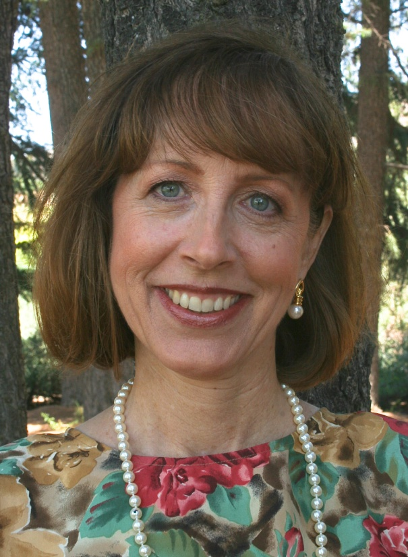 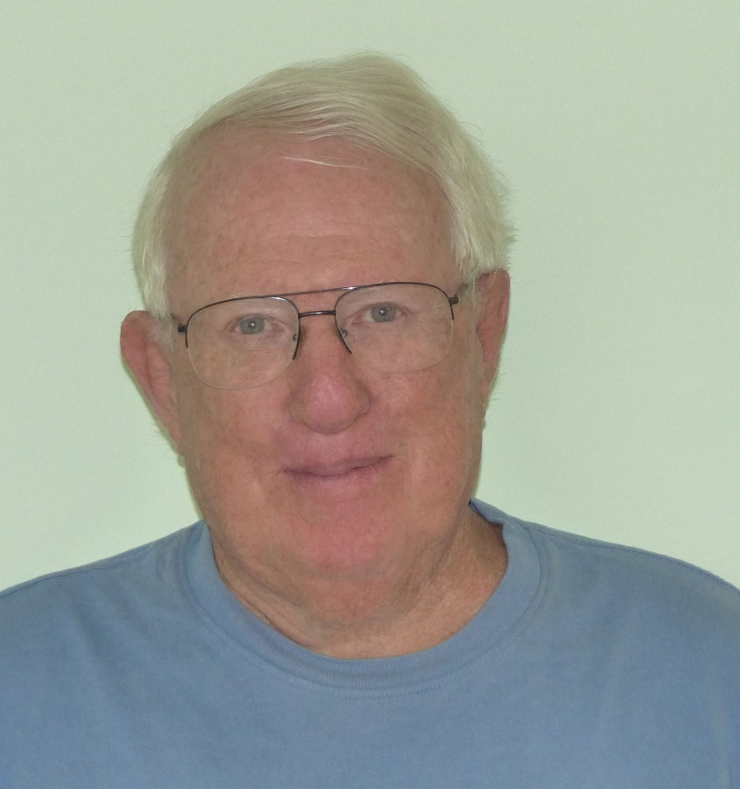 

**Lauralee McKay Bill Lavigne Diane DeLuca**

7:00 PM Announcements by President, **Billy Ocker**: 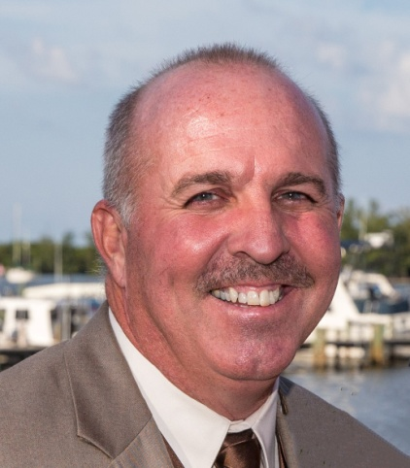

Treasurer, **Bobbi Whitlam**, will give Treasurer’s Report.

7:20 PM ***Members Sharing Photos of Circles Slide*** Show by **Mary Ester Bollis**

7:30 PM PROGRAM: *Winter Wildlife Photography*

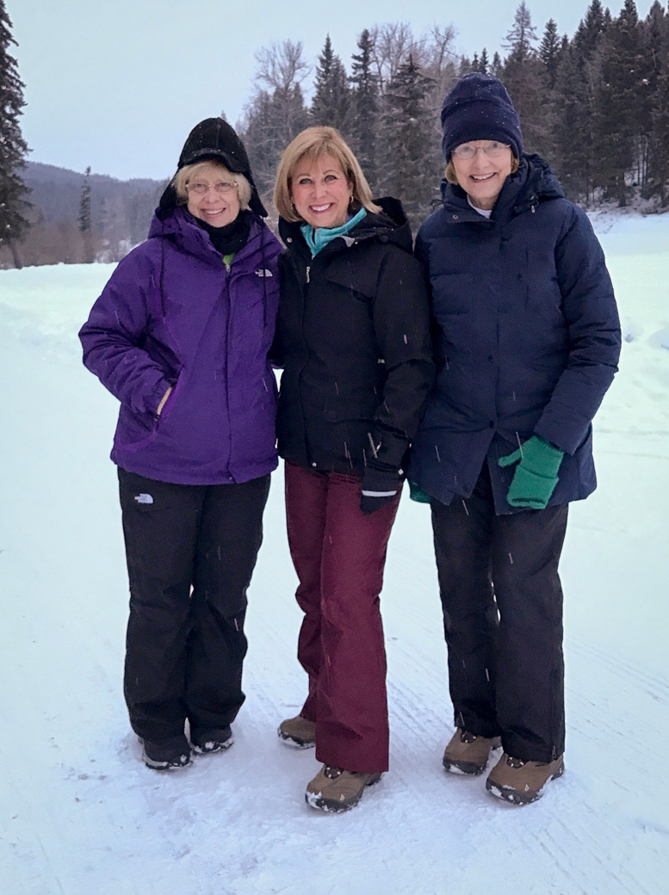 by outstanding, award winning photographers: **Gerri Mahon, Suzanne Kasvan, and Linda Leonard.**

8:30 PM Contest Theme**: *Interaction****.*

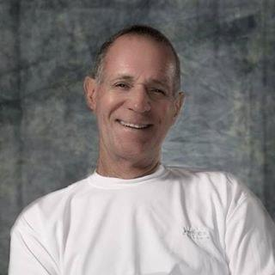Judge: Fine Art Professional Photographer, **Phil Reid**.

2017 Upcoming Events

**IRPC Members share one or two photos This month’s challenge: LEAF/LEAVES**

They will be shown in a slide show at the September 28th meeting.

There are only “2” rules:

1. MUST be taken between tonight (August 24th) and the **DEADLINE of SEPT 11th**
2. MUST be suitable for “family” viewing

Please email your photos to J.R.Williams [jrw527@bellsouth.net](mailto:jrw527@bellsouth.net)

Jpg. Format as an ATTACHMENT

**SEPTEMBER**

28TH Thursday....the September 28th Monthly IRPC Meeting:

*Let’s Get to Know Each Other Mini Exhibits:*

**Lila Ferrari, Michael Lowe, Hazel Lacks**

Members Share Photos of Leaves: Slide Show by Mary Ester Bollis

Program ***Black and White Imaging in Photography***

**by**  **Richard Thomson**

Contest Theme: *“Open”*

**OCTOBER **

**13TH Friday the 13th** Think Outside the Box #10 *Spooktacular* **Photography** . **Hosts: J.R. Williams & George Bollis**

Location: Riverside Park (N.W. corner, by Gazebos)

Time: 6:45 Set UP . 7:00 – 8:45 Photography . 9:00 PM Snacks After at Arby’s

**26TH Thursday the 26th IRPC Monthly Meeting**

*Let’s Get to Know Each Other Mini Exhibits:*

**Shelly Stang, Juanita Baker, Mary Lou Christie**

Members Share *Spooktacular* Photography Slide Show

PROGRAM:**Newspapers: *Film to Digital* by Mark Schumann**

Contest Theme: *“End of the Day”*

**NOVEMBER**

**4TH Saturday November 4th** Think Outside the Box #11: ***Posing and Photographing Family and Friends in an Outside Setting and Utilizing Natural light.* Seminar Instructors: Dick Robertson and Louie Ciszek** Hosts: J.R. Williams and George Bollis

Location: Riverside Park

Time: Shoot: 9:00 AM to 11:00 AM

Lunch: 11:00 AM Boston Market

**23rd** No Meeting (Happy Thanksgiving)

**DECEMBER**

**7TH Thursday December 7th** **CHRISTMAS SOCIAL**

Coffee/Tea/Cookies/Non-Messy-Finger Food

**Best Picture of the Year**

**11th Monday December 11th IRPC Juried Exhibit Intake**...

10:00 AM – 3:00 PM

**Exhibit Dates: December 17 thru January 4**



**2018 Indian River Photo Club Contest Themes:**

The IRPC Board of Directors decided to match, when possible, the photo themes of 2018, to the categories used for the local juried Photography Exhibits.

**IRCP THEMES FOR 2018**

January - People

February - Flora

March - Open

April - Fauna (IRPC VBM)/Animals & Wildlife (Backus)

May - Still Life (Backus)

Jun - Open

July - Scapes

August - Great Outdoors (Backus)

September - Open

October - Macro

**2017 PROGRAMS THAT HELP WITH THE CATEGORIES**  (1) Photographing Native Wildflowers with George Bollis (2) Portrait Photography with Phil Reid (3) *Winter Wildlife Photography” with* Gerri Mahon, Suzanne Kasvan & Linda Leonard (4) Black and White Imaging with Richard Thomson

**2017 THINK OUTSIDE THE BOX EVENTS THAT HELP W/ CATEGORIES** (1) Wildlife Photography at T.M. Goodwin (2) Food Still Life Photography at Charles Park Happy (3) Crazy Fun Still Life Photography at Riverside Park (4) 2 Night Photography Learning Events (5) Posing and Photographing Family and Friends In an Outside Setting . . Utilizing Natural light with Dick Robertson and Louie Cszek.

**INDIAN RIVER PHOTO CLUB PRINT COMPETITION**

(In-take in December with Exhibit in December/January)

PEOPLE - Posed or candid, portraits or groups

NATURE - Flora- Flowers, plants, etc.

Fauna- Animals, birds, etc.

As noted above, Nature is split into two categories. Evidence of

human influence will be allowed, but the subject should be

primarily natural.

STILL LIFE - Arrangements, natural or man-made, of inanimate objects

SCAPES - Landscapes, seascapes, cityscapes

SPECIAL TECHNIQUE - Out of the ordinary techniques, digitally altered

images of any subject.*

OPEN - Abstracts and images that don't fit the other categories.

**BACKUS MUSEUM CATEGORIES**

(In-Take in May Exhibit in June)

FILM/TRADITIONAL RAW PHOTOGRAPHY – Color and B & W,

All SUBJECTS - (negative or slide required) See FREQUENTLY ASKED QUESTIONS

for further explanation.)

DIGITAL - Great Outdoors - Plant, wildlife & animals - (no file required)

DIGITAL - Great Outdoors - Scenery, structures, cars, boats, etc. (no

file required)

DIGITAL - Color Still Life/Portrait (no file required)

DIGITAL - Black & White - Any subject (no file required)

MANIPULATED IMAGERY - Any subject (no file required)

**FROM THE HEART: TREASURE COAST PHOTOGRAPHY CENTER)**

(On line submission is generally August and September with Exhibit in Nov)

**Animals:  (Any animal or insect) Flora/Landscape People:  Be s**ure you have signed model releases, available upon request, for any recognizable people in these photos. **Open:** unrestricted creative license, altered in software like Photoshop. **The basic image must be photographic in origin, not a graphic design.** HDR and stitched panoramas. This category also includes architectural subjects, cityscapes, urban scapes and still life.

**JUDGED (non-juried) PHOTO CONTESTS**

**Pelican Island Audubon Society Bird of the Month** (Take-in Last day of month) **Pelican Island Preservation Society** (Take-in in March)